### Homework 13

Problem 1:

voltage = [0, 3, 6, 9, 12, 15, 18, 21];

current = [0, 0.5, 1.0, 1.48, 1.90, 2.32, 2.64, 2.98];

% Create a range of voltage values for the best-fitting line

voltage_range = linspace(min(voltage), max(voltage), 100);

current_fit = polyval(coefficients, voltage_range);

figure;

plot(voltage, current, 'o', 'MarkerSize', 8, 'LineWidth', 1.5);

hold on;

plot(voltage_range, current_fit, 'r-', 'LineWidth', 2);

% Add labels and a legend

xlabel('Voltage (V)');

ylabel('Current (A)');

title('Best-Fitting Straight Line');

legend('Actual Data', 'Best-Fitting Line');

% Display the slope and intercept

disp(['Best-fitting line equation: i = ' num2str(slope) ' * v + ' num2str(intercept)]);

a = coefficients(1);

disp(['Value of coefficient a: ' num2str(a)]);

b = coefficients(2);

disp(['Value of coefficient b: ' num2str(b)]);

v_target = 10.5;

current_at_10_5V = polyval(coefficients, v_target);

disp(['Current at v = 10.5 V: ' num2str(current_at_10_5V)]);

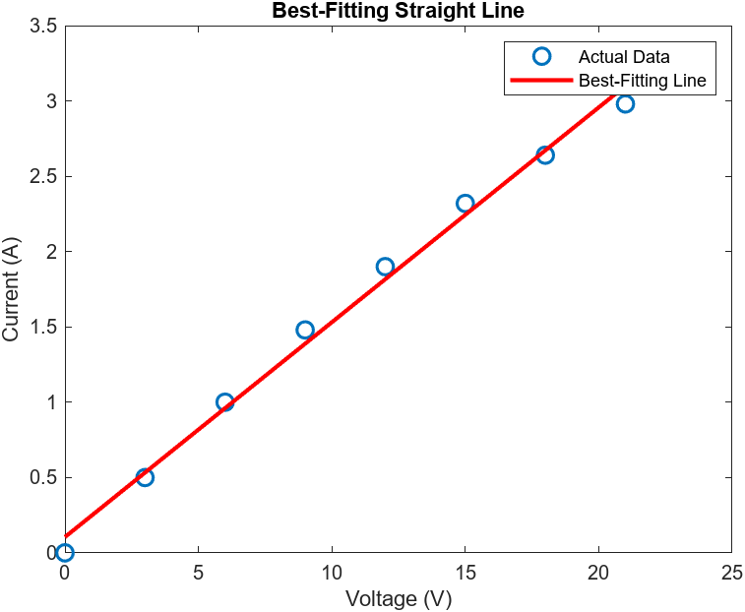

Best-fitting line equation: i = 0.14262 * v + 0.105

Value of coefficient a: 0.14262

Value of coefficient b: 0.105

Current at v = 10.5 V: 1.6025

Problem 2:

voltage = [0, 3, 6, 9, 12, 15, 18, 21];

current = [0, 0.5, 1.0, 1.48, 1.90, 2.32, 2.64, 2.98];

% Fit a second-degree polynomial to the data

coefficients_2nd_degree = polyfit(voltage, current, 2);

% Extract the coefficients for the second-degree polynomial

a2 = coefficients_2nd_degree(1);

a1 = coefficients_2nd_degree(2);

a0 = coefficients_2nd_degree(3);

% Create a range of voltage values for the best-fitting curve

voltage_range = linspace(min(voltage), max(voltage), 100);

% Calculate the corresponding current values using the second-degree polynomial

current_fit_2nd_degree = polyval(coefficients_2nd_degree, voltage_range);

% Plot the data points and the best-fitting curve

figure;

plot(voltage, current, 'o', 'MarkerSize', 8, 'LineWidth', 1.5);

hold on;

plot(voltage_range, current_fit_2nd_degree, 'r-', 'LineWidth', 2);

% Add labels and a legend

xlabel('Voltage (V)');

ylabel('Current (A)');

title('Best-Fitting Second Degree Polynomial');

legend('Actual Data', 'Best-Fitting Curve');

% Display the coefficients of the second-degree polynomial

disp(['Coefficients of the second-degree polynomial:']);

disp(['Coefficient a2: ' num2str(a2)]);

disp(['Coefficient a1: ' num2str(a1)]);

disp(['Coefficient a0: ' num2str(a0)]);

% Find the current for v = 14 V

v_target = 14;

current_at_14V = polyval(coefficients_2nd_degree, v_target);

disp(['Current at v = 14 V: ' num2str(current_at_14V)]);

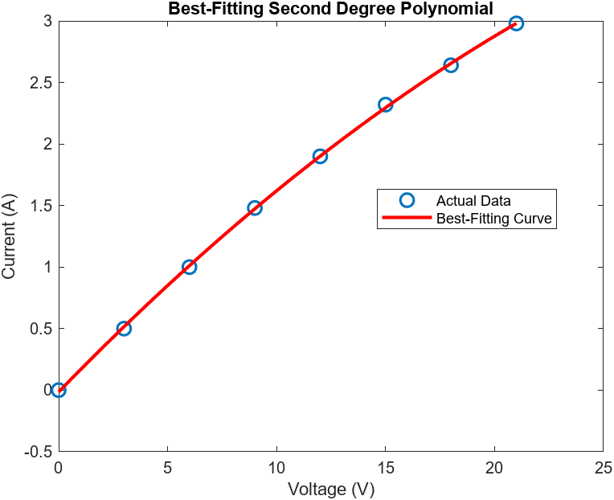

Coefficients of the second-degree polynomial:

Coefficient a2: -0.0018915

Coefficient a1: 0.18234

Coefficient a0: -0.014167

Current at v = 14 V: 2.1679

Problem 3:

% Define the function

f = @(x) exp(-x.^2 / 2);

% Generate x values with a step size of 0.1 from -3 to 3

x = -3:0.1:3;

% Generate y values for the actual points

y_actual = f(x);

% (a) Fit a 2nd degree polynomial

p2 = polyfit(x, y_actual, 2);

y_fit_2 = polyval(p2, x);

% (b) Fit a 4th degree polynomial

p4 = polyfit(x, y_actual, 4);

y_fit_4 = polyval(p4, x);

% (c) Fit a 6th degree polynomial

p6 = polyfit(x, y_actual, 6);

y_fit_6 = polyval(p6, x);

% Plot the results

figure;

subplot(3,1,1);

plot(x, y_actual, 'o', x, y_fit_2);

title('2nd Degree Polynomial Fit');

legend('Actual Points', '2nd Degree Fit');

subplot(3,1,2);

plot(x, y_actual, 'o', x, y_fit_4);

title('4th Degree Polynomial Fit');

legend('Actual Points', '4th Degree Fit');

subplot(3,1,3);

plot(x, y_actual, 'o', x, y_fit_6);

title('6th Degree Polynomial Fit');

legend('Actual Points', '6th Degree Fit');

% (Q.8) Coefficient 2a in the 2nd degree polynomial fit

coeff_2a_2nd = p2(2)

% (Q.9) Coefficient 3a in the 4th degree polynomial fit

coeff_3a_4th = p4(3)

% (Q.10) Coefficient 0a in the 4th degree polynomial fit

coeff_0a_4th = p4(1)

% (Q.11) Coefficient 6a in the 6th degree polynomial fit

coeff_6a_6th = p6(6)

% (Q.12) Coefficient 2a in the 6th degree polynomial fit

coeff_2a_6th = p6(2)

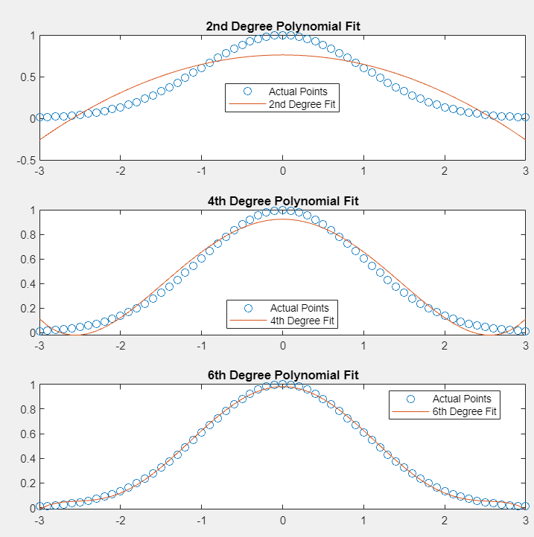

p2 = -0.1133 -0.0000 0.7613

p4 = **0.0222** 0.0000 -0.2899 -0.0000 0.9253

p6 = -0.0032 0.0000 0.0631 -0.0000 -0.4166 0.0000 0.9812